Project Design Phase-II Technology Stack (Architecture & Stack)

Date | 25 SEPTEMBER 2026
Team ID | SWTID-2026-4636
Project Name | AI BLOGNEXT
Maximum Marks | 4 Marks

Technical Architecture:
The Deliverable shall include the architectural diagram as below and the information as per the table1 & table 2

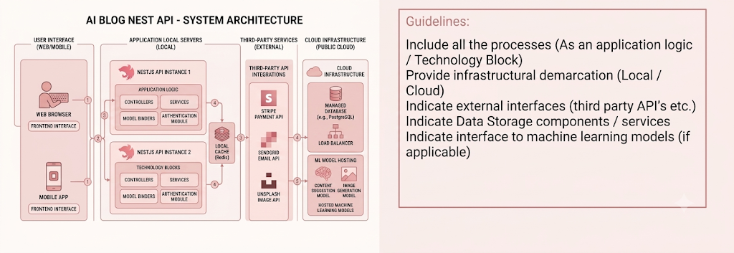
Table-1: Components & Technologies:

S.No | Component | Description | Technology
1 | User Interface | Provides an interface through which bloggers and content creators can register, log in, create blogs, manage posts, and use AI  content-generation features. | HTML, CSS,  JavaScript / React.js

2 | Application Logic-1 | Handles user registration, login, authentication, blog creation, updating,  viewing, and deletion. | Node.js, Express.js
3 | Application Logic-2 | Processes AI-based requests and generates blog content based on the topic or prompt  provided by the user. | Python / AI API
4 | Application Logic-3 | Handles authentication, validation, API  routing, error handling, and communication between the frontend and database. | Express.js, REST API
5 | Database | Stores user accounts, blog posts, categories,  generated content, and other application information. | MongoDB
6 | Cloud Database | Provides optional cloud-based database storage for accessing application data from  different environments. | MongoDB Atlas
7 | File Storage | Stores optional blog-related files such as images, documents, or other uploaded  content. | Local File System /  Cloud Storage
8 | External API-  1 | Provides AI-powered content generation  based on user-provided topics and prompts. | Generative AI  API
9 | External API-2 | Can be used to provide additional services such as image generation or other content-  related features. | Image/Content API
10 | Machine  Learning Model | Supports intelligent content generation,  content improvement, summarization, and other AI-assisted blogging functions. | Generative AI / NLP Model
11 | Infrastructure (Server / Cloud) | Hosts and runs the backend API and database services. The application can initially be developed locally and later  deployed to a cloud platform. | Node.js Server  / Cloud Hosting

Table-2: Application Characteristics:

S.No | Characteristics | Description | Technology
1 | Open-Source Frameworks | Uses open-source technologies for developing the frontend, backend, API services, and database integration. | Node.js, Express.js, React.js,  MongoDB
2 | Security Implementations | Protects user accounts and blog data using password hashing, JWT authentication, input validation, authorization, and protected API routes. | JWT,  bcrypt, HTTPS,  Input  Validation

3 | Scalable Architecture | Uses a modular REST API architecture where frontend, backend, database, and AI services can be developed and expanded  independently. | Node.js, Express.js, MongoDB  REST API
4 | Availability | The application can be deployed on a reliable cloud server and database service to allow users to access the system whenever the  service is available. | Cloud Hosting, MongoDB  Atlas
5 | Performance | Uses efficient REST APIs, database queries, validation, and modular backend processing to provide quick responses for blog management operations. AI requests are processed separately to avoid unnecessary  load on regular API operations. | Node.js, Express.js, MongoDB
Technology Stack Summary
Technology | Details
Frontend | HTML, CSS, JavaScript / React.js
Backend | Node.js + Express.js
Database | SQLite
Authentication | JWT + bcrypt
API | RESTful API
AI | Generative AI API / NLP Model
API Testing | Postman
Development Tool | Visual Studio Code
Version Control | Git / GitHub
Deployment | Local Server / Cloud Hosting
Data Format | JSON
Architecture | REST-based Client–Server Architecture

Technology Description
- Node.js: Used as the server-side JavaScript runtime.
- Express.js: Used to create RESTful API routes and handle HTTP requests.
- SQLite: Used as the lightweight relational database for storing users and blog information.
- JWT: Used for secure user authentication and protected API access.
- bcrypt: Used to securely hash user passwords.
- Generative AI API: Used for AI-powered blog content generation and summarization.
- Postman: Used to test API endpoints, authentication, request validation and responses.
- VS Code: Used as the primary development environment.
- JSON: Used for communication between the client and REST API.

